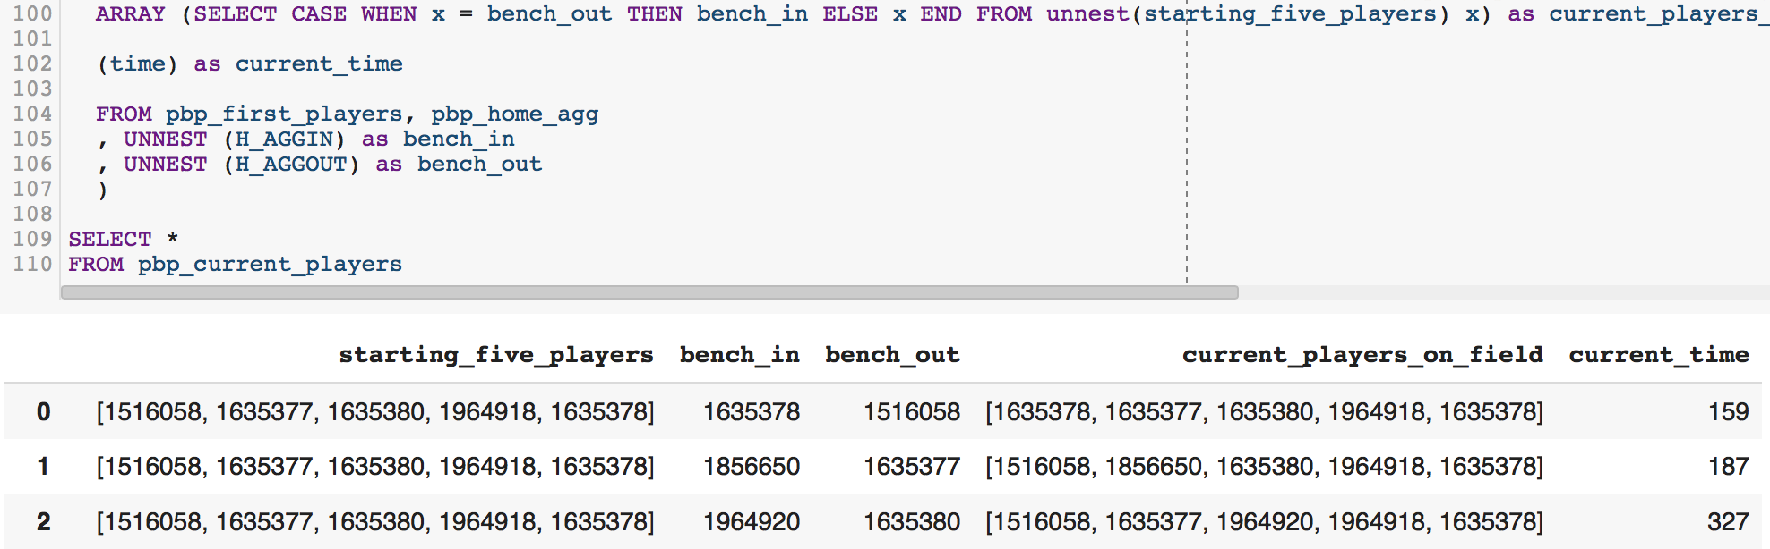

BigQuery Snippet Tracking the Current 5 Players on Court

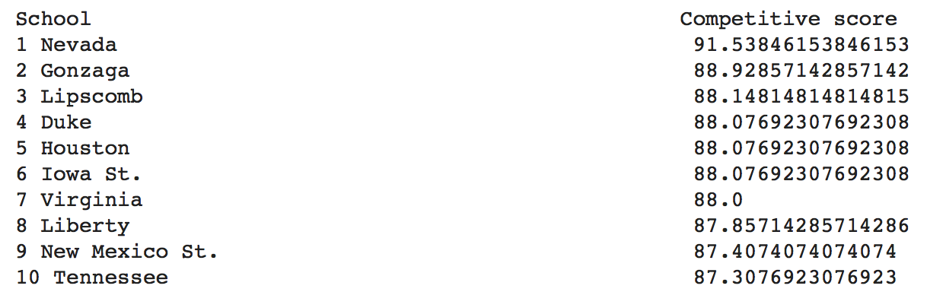

'18-'19 Division 1 Basketball Rankings by Competitiveness Through 3/14